**1. Design, Develop and Implement a menu driven Program in C for the following array operations.**

1. **Creating an array of N Integer Elements**
2. **Display of array Elements with Suitable Headings**
3. **Inserting an Element (ELEM) at a given valid Position (POS)**
4. **D) Deleting an Element at a given valid Position (POS)**

**E) Exit.**

**Support the program with functions for each of the above operations**

#include<stdio.h

#include<stdio.h>

#include<conio.h>

int search( int item, int a[ ], int n)

{

int low, high,key,mid;

low = 0; //Initialization

high = n-1; // Initialization

key=item;

while( low <= high )

{

mid = ( low + high ) / 2; // Find the mid-point

if ( key == a[mid] )

{

// If item not found, return position

return mid;

}

if( key < a[mid] )

high = mid - 1; // Search left side

else

low = mid + 1; // Search right side

}

return -1; // Item not found

}

void main( )

{

int i,item,a[10],n,pos;

printf("Enter the size of an Array\n");

scanf("%d",&n);

printf("Enter the Array Elements\n");

for(i=0;i<n;i++)

scanf("%d",&a[i]);

printf("The Array Elements are\n");

for(i=0;i<n;i++)

printf("%d\n",a[i]);

printf("Enter the Element to be searched\n");

scanf("%d",&item);

pos=search(item,a,n);

if(pos==-1)

printf("Item not found\n");

else

printf("Item found\n");

getch( );

}

**Output:**

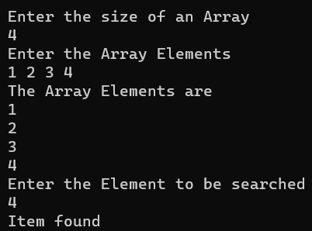

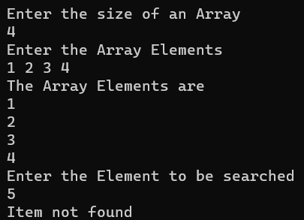

**2. Design, develop and Implement a Program in C for the following operations on Strings.**

1. **Read a main String (STR), a Pattern String (PAT) and a Replace String**

**(REP)**

1. **Perform Pattern Matching Operation: Find and Replace all occurrences of PAT in STR with REP if PAT exists in STR.**

**Report suitable messages in case PAT does not exist in STR**

**Support the program with functions for each of the above operations. Don't use Built-in functions.**

#include<stdio.h>

#include<conio.h>

char str[50], pat[20], rep[20], ans[50];

int c=0, m=0, i=0, j=0, k, flag=0;

void stringmatch(){

while(str[c] !='\0'){

if(str[m] == pat[i]){

i++;

m++;

if(pat[i] == '\0'){

flag = 1;

for(k=0; rep[k]!='\0'; k++, j++){

ans[j] = rep[k];

}

i = 0; c = m;

}

}

else{

ans[j]= str[c];

j++;

c++;

m=c;

i=0;

}

}

ans[j]='\0';

}

void main(){

printf("\nEnter the main string:"); gets(str);

printf("\nEnter the pat string:");

gets(pat);

printf("\nEnter the replace string:"); gets(rep);

stringmatch();

if(flag == 1)

printf("\nResultant string is %s", ans); else

printf("\nPattern string is not found");

}

**Output:**

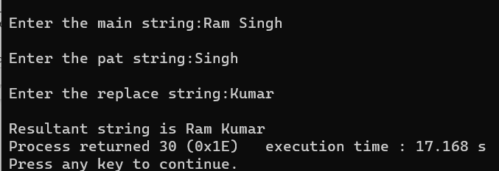

**3. Design, Develop and Implement a menu driven Program in C for the following operations on**

**STACK of Integers (Array Implementation of Stack with maximum size MAX)**

1. **Push an Element on to Stack**
2. **Pop an Element from Stack**
3. **Demonstrate how Stack can be used to check Palindrome**
4. **Demonstrate Overflow and Underflow situations on Stack**
5. **Display the status of Stack**
6. **Exit**

**Support the program with appropriate functions for each of the above operations**

#include<stdio.h>

#include<conio.h>

#define MAX 4

int stack[MAX], item;

int ch, top = -1, count = 0, status = 0;

/*PUSH FUNCTION*/

void push(int stack[], int item){

if (top == (MAX-1))

printf("\n\nStack is Overflow");

else{

printf("\nEnter a element to be pushed: ");

scanf("%d", &item);

stack[++top] = item;

status++;

}

}

/*POP FUNCTION*/

int pop(int stack[]){

int ret;

if(top == -1)

printf("\n\nStack is Underflow");

else

{

ret = stack[top--];

status--;

}

printf("\nPopped element is %d", ret);

return ret;

}

void palindrome(int stack[]){

int i, temp;

temp = status;

for(i=0; i<temp; i++)

{

if(stack[i] == pop(stack))

count++;

}

if(temp==count)

printf("\nStack contents are Palindrome");

else

printf("\nStack contents are not palindrome");

}

/*FUNCTION TO DISPLAY STACK*/

void display(int stack[]){

int i;

printf("\nThe stack contents are:");

if(top == -1)

printf("\nStack is Empty");

else{

for(i=top; i>=0; i--)

printf("\n -------\n| %d |", stack[i]);

}printf("\n");

}

void main(){

do{

printf("\n\n----MAIN MENU-----\n");

printf("\n 1. PUSH\n 2.POP\n 3.PALINDROME\n 4.Exit ");

printf("\nEnter Your Choice: ");

scanf("%d", &ch);

switch(ch){

case 1:

push(stack, item);

display(stack);

break;

case 2:

item=pop(stack);

display(stack);

break;

case 3:

palindrome(stack);

break;

case 4:

exit(0);

break;

default:

printf("\nEND OF EXECUTION");

}

}while (ch != 4);

getch();

}

**Output:**

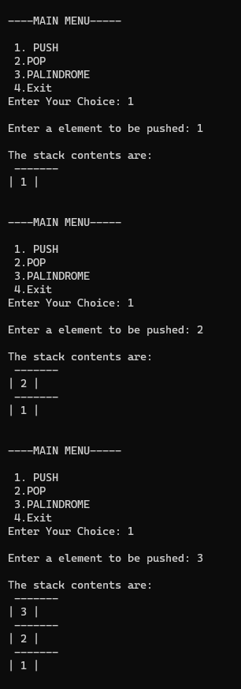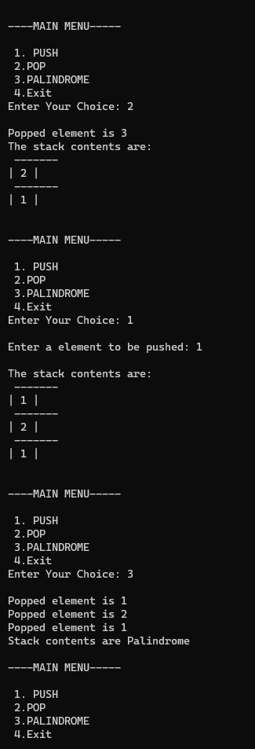

**4. Design, develop and Implement a Program in C for converting an Infix Expression to Postfix Expression. Program should support for both parenthesized and free parenthesized expressions with the operators: +, -, *, /, % (Remainder), ^ (Power) and alphanumeric operands.**

#include<stdio.h>

void infix_to_postfix();

void push(char);

char pop();

int priority(char);

char infix[30],postfix[30],stack[30];

int top=-1;

void push(char item){

stack[++top]=item;

}

char pop(){

return stack[top--];

}

int priority(char symb){

int p;

switch(symb){

case '+':

case '-':p=1;break;

case '*':

case '/':

case '%': p=2;break;

case '^':p=3;break;

case '(':

case ')':p=0;break;

case '#':p=-1; // stack contain nothing

break;

}

return p;

}

void infix_to_postfix(){

int i=0,j=0;

char symb,temp;

push('#');

for(i=0;infix[i]!='\0';i++){

symb=infix[i];

switch(symb){

case '(' :

push(symb);

break;

case ')' :

temp=pop();

while(temp!='('){

postfix[j++] = temp;

temp=pop();

}

break;

case '+':

case '-':

case '*':

case '/':

case '%':

case '^':

while(priority (stack[top])>=priority(symb)){

temp = pop();

postfix[j++]=temp;

}

push(symb);

break;

default : postfix[j++] = symb;

}

}

while(top>0){

temp =pop();

postfix[j++] = temp;

} postfix[j] = '\0';

}

void main(){

printf("Enter the valid infix expression \n");

scanf("%s",infix);

infix_to_postfix();

printf("\n Infix Expression : %s",infix);

printf("\n Postfix Expression : %s \n",postfix);

}

**Output:**

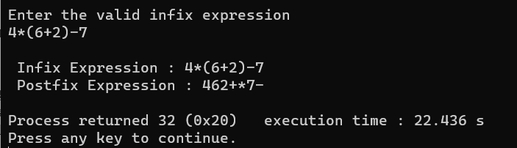

**5. Design, Develop and Implement a Program in C for the following Stack Applications. Evaluation of suffix expression with single digit operand and operators: +, -, *, /, %,^**

#include<stdio.h>

#include<math.h>

#include<string.h>

float compute(char symbol, float op1, float op2)

{

switch (symbol)

{

case '+':

return op1 + op2;

case '-':

return op1 - op2;

case '*':

return op1 * op2;

case '/':

return op1 / op2;

case '$':

case '^':

return pow(op1,op2);

default :

return 0;

}

}

void main()

{

float s[20], res, op1, op2;

int top, i;

char postfix[20], symbol;

printf("\nEnter the postfix expression:\n");

scanf ("%s", postfix);

top=-1;

for (i=0; i<strlen(postfix) ; i++)

{

symbol = postfix[i];

if(isdigit(symbol))

s[++top]=symbol - '0';

else

{

op2 = s[top--];

op1 = s[top--];

res = compute(symbol,op1, op2);

s[++top] = res;

}

}

printf("\nThe result is : %f\n", res);

}

**Output:**

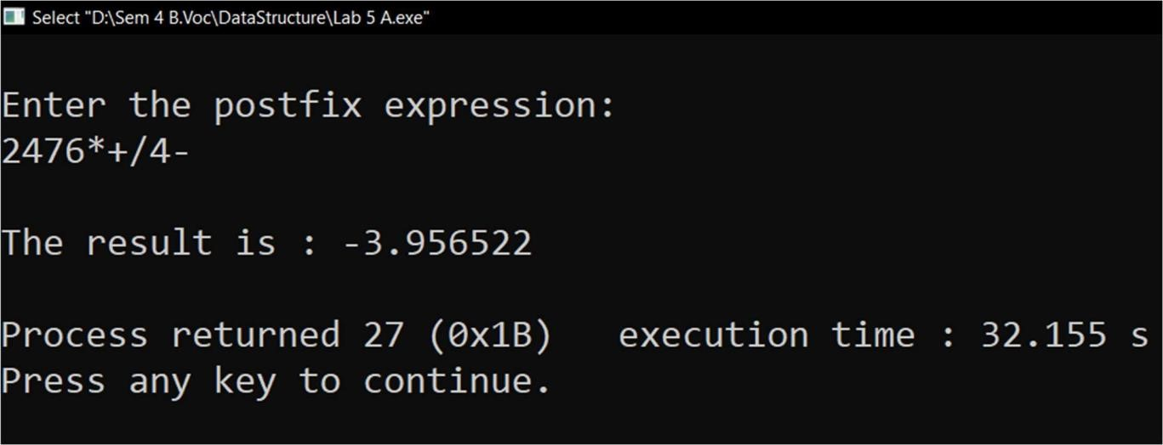

**6. Solving Tower of Hanoi problem with n disks**

#include<stdio.h>

#include<conio.h>

void tower(int n, int source, int temp,int destination)

{

if(n == 0)

return;

tower(n-1, source, destination, temp);

printf("\nMove disc %d from %c to %c", n, source, destination); // c= source tower to c= destination

tower(n-1, temp, source, destination); //n-1 means last disk

}

void main()

{

int n; // number of disks

printf("\nEnter the number of discs: \n");

scanf("%d", &n);

tower(n, 'A', 'B', 'C'); //it contains the n= number of disk, A,B,C : name of tower

getch();

}

**Output:**

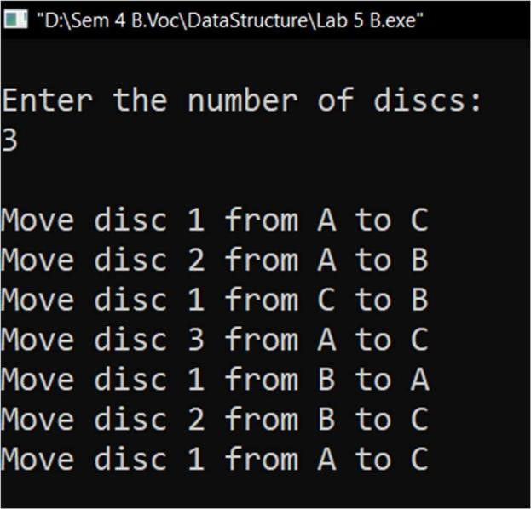

**7. Program to implement factorial of a number and to generate the Ackerman function using recursive**

#include<stdio.h>

#include<conio.h>

#include<stdlib.h>

int fact(int n){

if(n==0)

return 1;

return n*fact(n-1);

}

int A(int p,int q){

if(p==0)

return q+1;

else if(q==0)

return A(p-1,1);

else

return A(p-1,A(p,q-1));

}

void main(){

int n,p,q,ch;

while(1){

printf("\n 1.factorial\n 2.Ackerman Function\n 3.Exit\n");

printf("Enter your choice:\n");

scanf("%d",&ch);

switch(ch) {

case 1:printf("enter the value for n: ");

scanf("%d",&n);

printf("the factorial of %d=%d\n,n",fact(n));

break;

case 2:printf("enter the value for p and g:");

scanf("%d%d",&p,&q);

printf("\nOutput of Ackerman function:%d\n",A(p,q));

break;

case 3:exit(0);

default:printf("Invalid choice");

return;

}

}

}

**Output:**

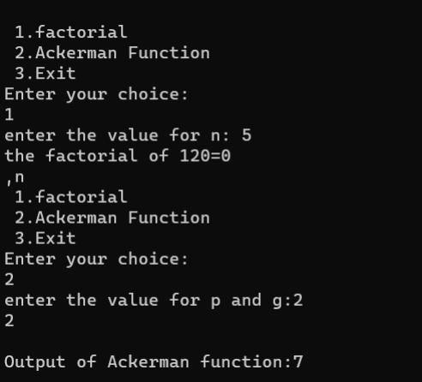

**8. Design, Develop and Implement a menu driven Program in C for the following operations on Circular QUEUE of Characters (Array Implementation of Queue with maximum size MAX)**

1. **Insert an Element on to Circular QUEUE**
2. **Delete an Element from Circular QUEUE**
3. **Demonstrate Overflow and Underflow situations on Circular QUEUE**
4. **Display the status of Circular QUEUE**
5. **Exit**

**Support the program with appropriate functions for each of the above operations**

#include<stdio.h>

#include<conio.h>

#define MAX 10

int ch, front = 0, rear = -1, count=0;

char q[MAX], item;

void insert(){

if(count == MAX){

printf("\nQueue is Full");

} else {

rear = (rear + 1)% MAX;

q[rear]=item;

count++;

}

}

void del(){

if(count == 0)

printf("\nQueue is Empty");

else {

if(front > rear && rear==MAX-1)

{

front=0; rear=-1; count=0;

} else{

item=q[front];

printf("\nDeleted item is: %c",item);

front = (front + 1)% MAX;

count--;

}

}

}

void display(){

int i, f=front, r=rear;

if(count == 0)

printf("\nQueue is Empty");

else {

printf("\nContents of Queue is:\n");

for(i=f; i!=r; i=(i+1)% MAX) {

printf("%c\t", q[i]);

}

printf("%c\t", q[i]);

}

}

void main(){

do {

printf("\n\n1. Insert\n2. Delete\n3. Display\n4. Exit");

printf("\nEnter the choice: ");

scanf("%d", &ch);

switch(ch) {

case 1: printf("\nEnter the character / item to be inserted: ");

scanf("%s",&item);

insert();

break;

case 2: del();

break;

case 3: display();

break;

case 4: exit(0);

break;

}

}while(ch!=4);

getch();

}

**Output:**

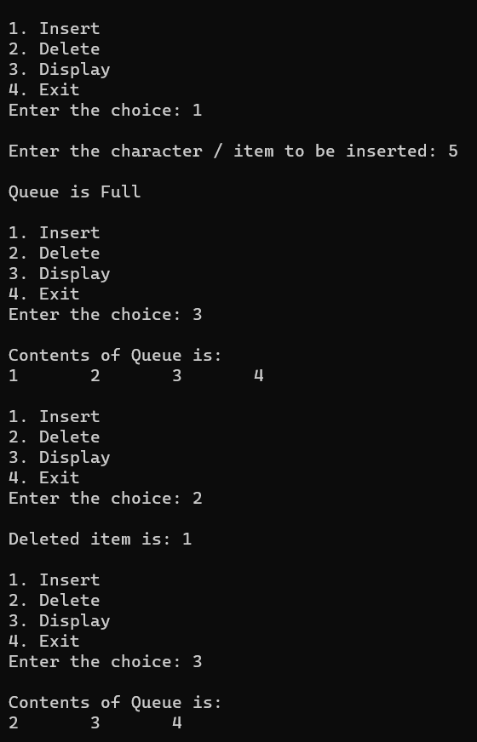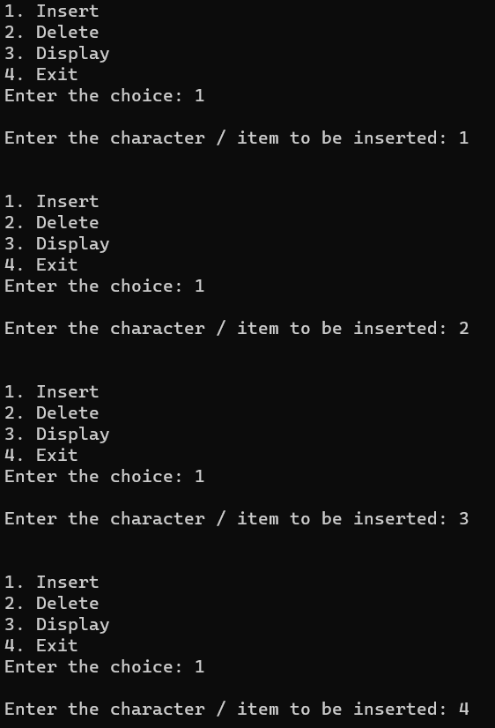

**9. Program to implement singly Linked list using Queue**

#include<stdio.h>

#include<stdlib.h>

// Node structure

struct node {

int info;

struct node *link;

};

// Function to create a new node

struct node* getnode() {

struct node* x = (struct node*)malloc(sizeof(struct node));

if(x == NULL) {

printf("Out of memory\n");

exit(0);

}

return x;

}

// Function to delete a node

void freenode(struct node *x) {

free(x);

}

// Function to insert a node at the rear end

struct node* insert_rear(int item, struct node *first) {

struct node *temp, *cur;

temp = getnode();

temp->info = item;

temp->link = NULL;

if(first == NULL) {

return temp;

}

cur = first;

while(cur->link != NULL) {

cur = cur->link;

}

cur->link = temp;

return first;

}

// Function to delete a node from the front end

struct node* delete_front(struct node *first) {

struct node *temp;

if(first == NULL) {

printf("List is empty, cannot delete\n");

return first;

}

temp = first;

first = first->link;

printf("Item deleted = %d\n", temp->info);

freenode(temp);

return first;

}

// Function to display the contents of the linked list

void display(struct node *first) {

struct node *temp;

if(first == NULL) {

printf("List is empty\n");

return;

}

printf("The contents of singly linked list:\n");

temp = first;

while(temp != NULL) {

printf("%d ", temp->info);

temp = temp->link;

}

printf("\n");

}

// Main function

int main() {

struct node *first = NULL;

int ch, item;

while(1) {

printf("\n1. Insert Rear\n2. Delete Front\n3. Display\n4. Exit\n");

printf("Enter your choice: ");

scanf("%d", &ch);

switch(ch) {

case 1:

printf("Enter the element to be inserted: ");

scanf("%d", &item);

first = insert_rear(item, first);

break;

case 2:

first = delete_front(first);

break;

case 3:

display(first);

break;

case 4:

exit(0);

default:

printf("Invalid choice, please try again.\n");

}

}

return 0;

}

**Output:**

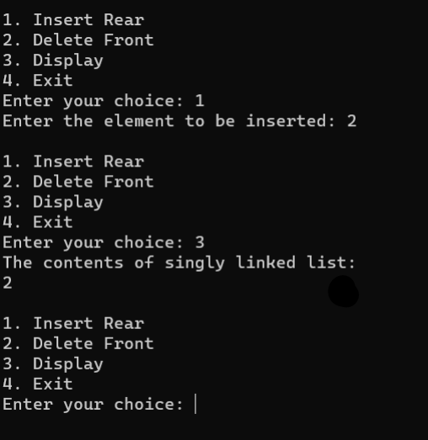

**10** **. Program to implement Binary tree traversal**

#include <stdio.h>

#include <stdlib.h>

struct Node {

int data;

struct Node* left;

struct Node* right;

};

struct Node* createNode(int val) {

struct Node* newNode = malloc(sizeof(struct Node));

newNode->data = val;

newNode->left = newNode->right = NULL;

return newNode;

}

void inorder(struct Node* root) {

if (root) {

inorder(root->left);

printf("%d ", root->data);

inorder(root->right);

}

}

void preorder(struct Node* root) {

if (root) {

printf("%d ", root->data);

preorder(root->left);

preorder(root->right);

}

}

void postorder(struct Node* root) {

if (root) {

postorder(root->left);

postorder(root->right);

printf("%d ", root->data);

}

}

struct Node* insertNode(struct Node* node, int val) {

if (!node)

return createNode(val);

if (val < node->data)

node->left = insertNode(node->left, val);

else if (val > node->data)

node->right = insertNode(node->right, val);

return node;

}

int main() {

struct Node* root = NULL;

int choice, item;

while (1) {

printf("1. Insert 2. Inorder 3. Preorder 4. Postorder 5. Exit\n");

printf("Enter your choice: ");

scanf("%d", &choice);

switch (choice) {

case 1:

printf("Enter the element to be inserted: ");

scanf("%d", &item);

root = insertNode(root, item);

break;

case 2:

printf("Inorder traversal: ");

inorder(root);

printf("\n");

break;

case 3:

printf("Preorder traversal: ");

preorder(root);

printf("\n");

break;

case 4:

printf("Postorder traversal: ");

postorder(root);

printf("\n");

break;

case 5:

exit(0);

default:

printf("Invalid choice\n");

}

}

return 0;

}

**Output:**

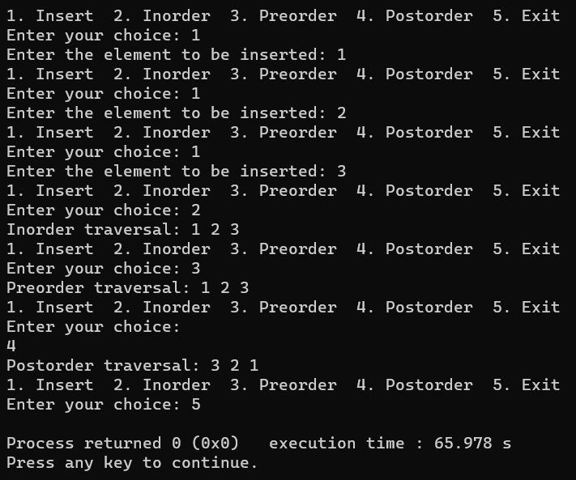

## 11. Program to implement Binary Search

#include<stdio.h>

#include<conio.h>

int search( int item, int a[ ], int n)

{

int low, high,key,mid;

low = 0; //Initialization

high = n-1; // Initialization

key=item;

while( low <= high )

{

mid = ( low + high ) / 2; // Find the mid-point

if ( key == a[mid] )

{

// If item not found, return position

return mid;

}

if( key < a[mid] )

high = mid - 1; // Search left side

else

low = mid + 1; // Search right side

}

return -1; // Item not found

}

void main( )

{

int i,item,a[10],n,pos;

printf("Enter the size of an Array\n");

scanf("%d",&n);

printf("Enter the Array Elements\n");

for(i=0;i<n;i++)

scanf("%d",&a[i]);

printf("The Array Elements are\n");

for(i=0;i<n;i++)

printf("%d\n",a[i]);

printf("Enter the Element to be searched\n");

scanf("%d",&item);

pos=search(item,a,n);

if(pos==-1)

printf("Item not found\n");

else

printf("Item found\n");

getch( );

}

**Output:**

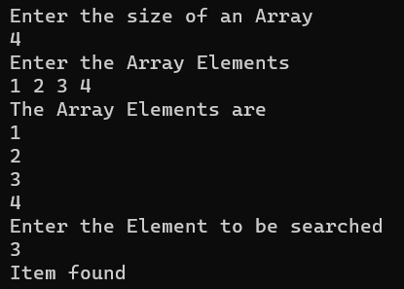

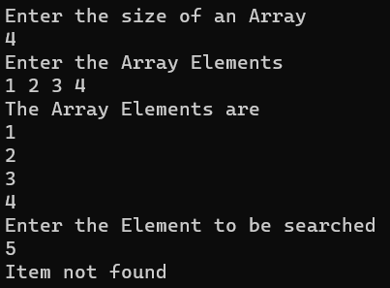

## 12. Implement bubble sort to sort a given array in c programming

#include<stdio.h>

void main( ){

int n,i,j,temp,a[20],pos;

printf(“Enter the number of items\n”);

scanf(“%d”,&n);

printf(“Enter the items to sort\n”);

for(i=0;i<n;i++)

sacnf(“%d”,&a[i]);

for(i=0;i<n-1;i++){

pos=i;

for(j=i+1;j<n;j++){

if(a[j]<a[pos])

pos=j;

}

temp=a[pos];

a[pos]=a[i];

a[i]=temp;

}

printf(“The sorted items are\n”);

for(i=0;i<n;i++)

printf(“%d\n”,a[i]);

}

**Output:**

